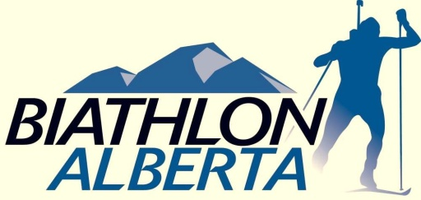
Aiming for Excellence
Team Alberta Coaching and Support Staff Selection Process
2013 National Championships
____________________________________________________________________________
- Principles: The primary goals of the process are to ensure an optimal experience for athletes, maximize availability of coaches for athletes, and provide opportunities for coaching development and mentorship.
- Coach Staffing Process: All Alberta-based coaches may apply. There are up to five coaching positions to be filled. The position of Head Coach will be filled by Richard Boruta, Head Coach of the Biathlon Alberta Training Centre. Richard Pettit will be the Head Wax Technician. Additional wax tech positions will be filled as determined by the Head Coach. The desired athlete-to-coach ratio is 5:1. This ratio may be adjusted to accommodate for budget constraints. Applications will be reviewed by a three-person Team Alberta Staffing Selection Committee, comprised of: VP Technical, Director of Coaching Development, and one non-Board member of Biathlon Alberta.
3. Coach Staffing Criteria:
- Number of Team Alberta qualifying athletes currently coached
- Coaching Experience and Performance – success as measured by key achievements in past 5 seasons and years of experience
- Training and certification – including professional development
- Development – What are the coach’s goals for their own development and what experience is required for them to reach this goal.

Coaches selected to positions with Team Alberta must provide a Criminal Record Check, including Vulnerable Sector Verification, dated March 2010 or later. Coaches working for Team Alberta are subject to the Biathlon Alberta Coach/Manager Screening Policy and Code of Ethics.

Note: Interested coaches of all experience levels are encouraged to apply, including those potentially with few or no attending athletes.

4. Roster (number and staffing may vary with team size and composition):
- Head Coach – Richard Boruta
- Up to 5 Assistant Coaches
- Wax Tech – Richard Pettit
- Logistics Manager – TBA
Note: Additional Wax Techs will be selected from the Assistant Coaches
5. Deadlines: Applications must be submitted to BA office via e-mail by 21 Dec., 2012

TEAM ALBERTA COACHING APPLICATION

Coach Personal Information
Name:
Street Address:
Phone:
Email:
Club:

NCCP Coaching Experience*
Highest level NCCP completed:
Other relevant education or training:
Driver’s License Class:
Year of Coaching Experience:
Key Achievements/Successes:
Development: How will attending Nationals aid your development as a coach?
Please list the 3 most relevant skills you can contribute to Team Alberta:
*additional information, including resume, would be appreciated

Application deadline: December 21st, 2012
Please send applications to: info@biathlon.ca

