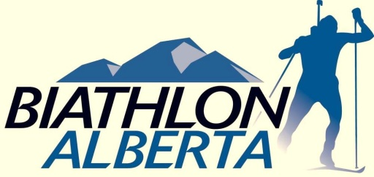
Aiming for Excellence
Team Alberta Coaching and Support Staff Selection Process
2014 National Championships
Charlo, New Brunswick March 9 – 17
____________________________________________________________________________
- Principles: The primary goals of the process are to ensure an optimal experience for athletes, maximize availability of coaches for athletes, and provide opportunities for coaching development and mentorship.

- Coach Staffing Process: Up to four coaching positions will be filled through the selection process. The position of Head Coach will be filled by Richard Boruta of the Biathlon Alberta Training Centre. One of the Assistant Coach positions will be filled by Lowell Niven, head coach of the Augustana/Camrose Biathlon Team. Additional wax tech positions will be filled as determined by the Head Coach.

- Coach Staffing Criteria will include, but not be limited to, the following:
- Training and certification – including professional development
- Coaching experience and success
- Development – What are the coach’s goals for their own development and what experience is required for them to reach these goals

Coaches selected to positions with Team Alberta must provide a Criminal Record Check, including Vulnerable Sector Verification, dated March 2011 or later. Coaches are subject to the Biathlon Alberta Coach/Manager Screening Policy and Code of Ethics.

Note: Interested coaches of all experience levels are encouraged to apply

4. Roster (number and staffing may vary with team size and composition):
- Head Coach – Richard Boruta
- Assistant Coach – Lowell Niven
- Up to 5 Assistant Coaches
- Head Wax Tech – TBA
- Logistics Manager – TBA
Note: Additional Wax Techs will be selected from the Assistant Coaches

5. Deadlines: Applications must be submitted to BA office via e-mail by Nov. 30, 2013

TEAM ALBERTA COACHING APPLICATION

Coach Personal Information
Name:
Street Address:
Phone:
Email:
Club:
NCCP CC#:

NCCP Coaching Experience*
Highest level NCCP completed:
Other relevant education or training:
Driver’s License Class:
Year of Coaching Experience:
Key Achievements/Successes:
Development: How will attending Nationals aid your development as a coach?
Please list the 3 most relevant skills you can contribute to Team Alberta:
*additional information, including resume, would be appreciated

Application deadline: November 30, 2013
Please send applications to: info@biathlon.ca

