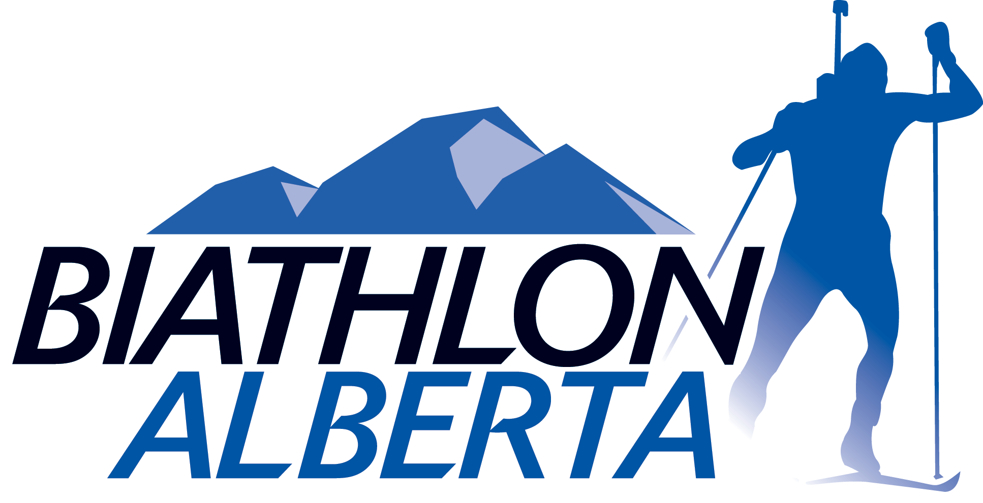

I, _____________________________________, a member of Team Alberta for the 2015 National Biathlon Championships agree to the following terms and conditions of participation with Team Alberta (please initial each line):

_____ I agree to compete in the following events: Sprint, Pursuit, Mass Start or Individual, and Mixed Relay.

_____ I agree to represent the province of Alberta, and Biathlon Alberta, in a dignified and responsible manner.

_____ I agree to compete within both the spirit and letter of the International Biathlon Union and Biathlon Canada competition rules.

_____ I agree to abide by the laws of Canada, and the jurisdiction(s) traveled to.

_____ I acknowledge that breach of any of the above points may result in my immediate dismissal from Team Alberta, including expedited return to Alberta at my expense. Dismissal may also disqualify me from future Team Alberta Tours and activities.

Athlete Signature: ___________________________________

Guardian Signature
(for athletes under 18 years of age): ___________________________________

Date: ___________________________________

