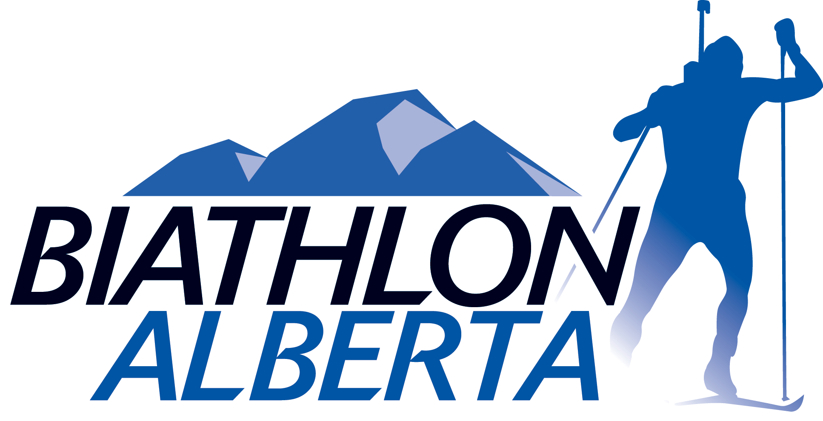2015 CANADA WINTER GAMES – TRAINING CAMP 3
203 Bob Niven Training Centre
88 Canada Olympic Road SW
Calgary, AB T3B 5R5
Telephone: 403.202.6548
info@biathlon.ca www.biathlon.ca
Aiming for Excellence
CANMORE, October 22 - 27, 2013

REGISTRATION FORM

PARTICIPANT INFORMATION*

LAST NAME:

FIRST NAME:

STREET ADDRESS:

ACCOMMODATION REQUIRED?

EMAIL ADDRESS:

PHONE :

DATE-OF-BIRTH:

EMERGENCY CONTACT - NAME:

EMERGENCY CONTACT - PHONE:

MEDICAL/ALLERGY INFORMATION:

*This camp is open to Biathlon Alberta athletes born 1994 through 1997
**Please complete and return this form to geretcoyne@gmail.com. Payment may be made by cheque ($200 made out to “Biathlon Alberta”) to the address listed above.

